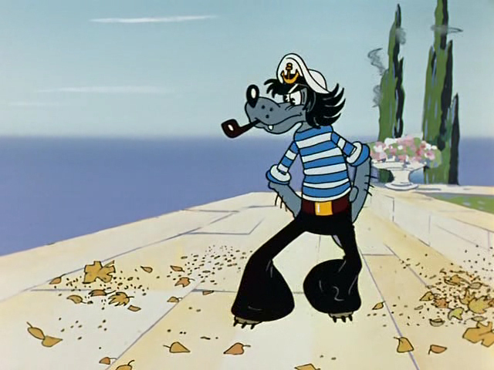

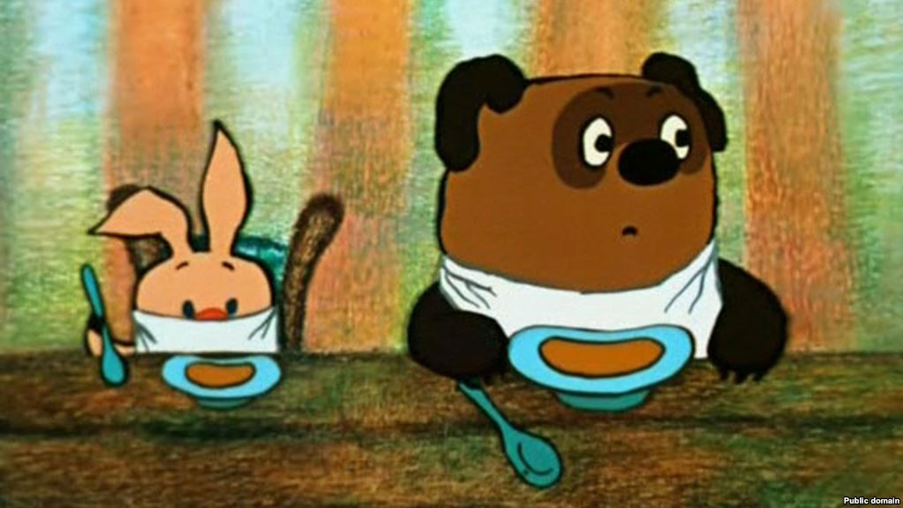

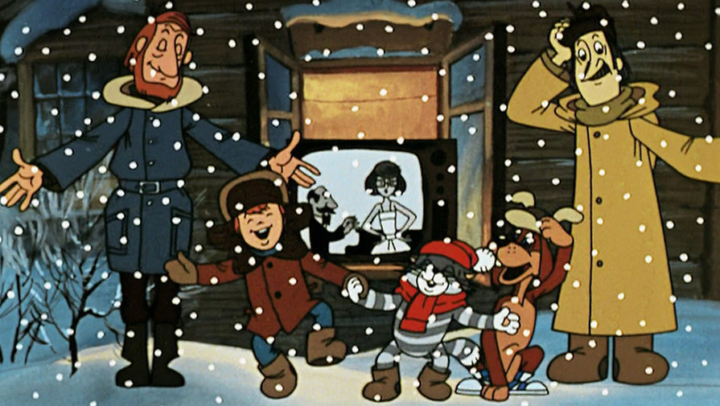



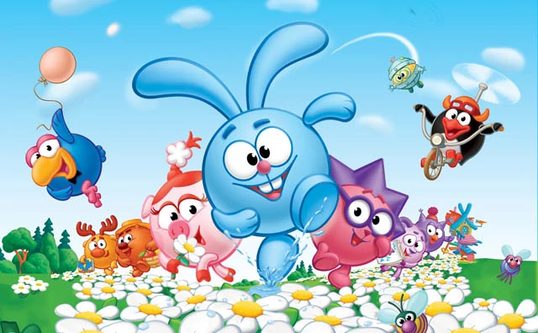

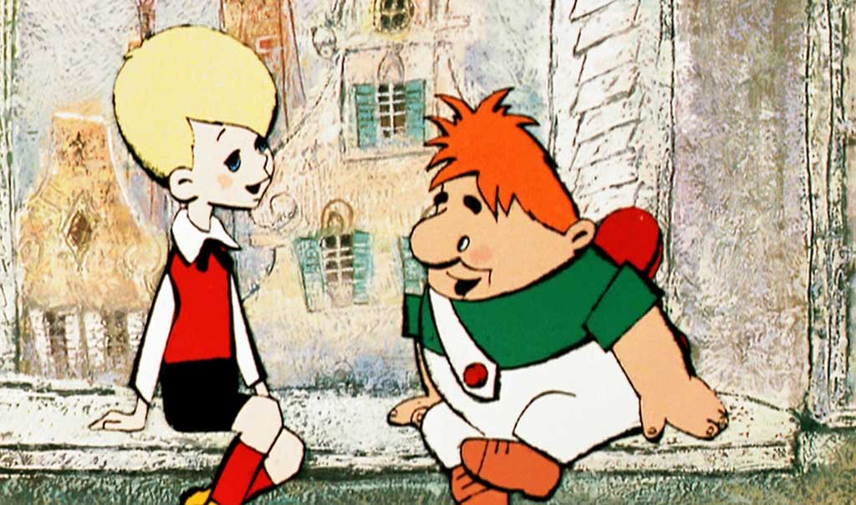

**ЗАДАНИЕ 1. КОМАНДА 1.**

Ваш мультфильм ______________________________________________________________

В чём заключается суть оригинального мультфильма?

___________________________________________________________________________________________________________________________________________________________________________________________________________________________________________________

Как Вы хотите мультфильм переделать? Как вы видите сюжет мультфильма в современной реальности?

___________________________________________________________________________________________________________________________________________________________________________________________________________________________________________________

ОТВЕТ:

___________________________________________________________________________________________________________________________________________________________________________________________________________________________________________________________________________________________________________________________________________________________________________________________________________________________________________________________________________________________________________________________________________________________________________________________________________________________________________________________________________________________________________________________________________________________________________________________________________________________________________________________________________________________________________________________________________________________________________________________________________________________________________________________________________________________________________________________________________________________________________________________________________________________________________________________________________________________________________________________________________________________________________________________________________________________________________________________________________________________________________________________________________________________________________________________________________________________________________________________________________________________________________________________________________________________________________________________________________________________________________________________________________________________________________________________________________________________________________________________________________________________________________________________________________________________________________________________________________________________________________________________________________________________________________________________________________

**ЗАДАНИЕ 1. КОМАНДА 2.**

Ваш мультфильм ______________________________________________________________

В чём заключается суть оригинального мультфильма?

___________________________________________________________________________________________________________________________________________________________________________________________________________________________________________________

Как Вы хотите мультфильм переделать? Как вы видите сюжет мультфильма в современной реальности?

___________________________________________________________________________________________________________________________________________________________________________________________________________________________________________________

ОТВЕТ:

___________________________________________________________________________________________________________________________________________________________________________________________________________________________________________________________________________________________________________________________________________________________________________________________________________________________________________________________________________________________________________________________________________________________________________________________________________________________________________________________________________________________________________________________________________________________________________________________________________________________________________________________________________________________________________________________________________________________________________________________________________________________________________________________________________________________________________________________________________________________________________________________________________________________________________________________________________________________________________________________________________________________________________________________________________________________________________________________________________________________________________________________________________________________________________________________________________________________________________________________________________________________________________________________________________________________________________________________________________________________________________________________________________________________________________________________________________________________________________________________________________________________________________________________________________________________________________________________________________________________________________________________________________________________________________________________________________

**ЗАДАНИЕ 2. КОМАНДА 1.**

Какой мультфильм вы узнали в тексте другой команды? ______________________________________________________________

В чём заключается суть оригинального мультфильма?

___________________________________________________________________________________________________________________________________________________________________________________________________________________________________________________

ОТВЕТ:

___________________________________________________________________________________________________________________________________________________________________________________________________________________________________________________________________________________________________________________________________________________________________________________________________________________________________________________________________________________________________________________________________________________________________________________________________________________________________________________________________________________________________________________________________________________________________________________________________________________________________________________________________________________________________________________________________________________________________________________________________________________________________________________________________________________________________________________________________________________________________________________________________________________________________________________________________________________________________________________________________________________________________________________________________________________________________________________________________________________________________________________________________________________________________________________________________________________________________________________________________________________________________________________________________________________________________________________________________________________________________________________________________________________________________________________________________________________________________________________________________________________________________________________________________________________________________________________________________________________________________________________________________________________________________________________________________________

**ЗАДАНИЕ 2. КОМАНДА 2.**

Какой мультфильм вы узнали в тексте другой команды? ______________________________________________________________

В чём заключается суть оригинального мультфильма?

___________________________________________________________________________________________________________________________________________________________________________________________________________________________________________________

ОТВЕТ:

___________________________________________________________________________________________________________________________________________________________________________________________________________________________________________________________________________________________________________________________________________________________________________________________________________________________________________________________________________________________________________________________________________________________________________________________________________________________________________________________________________________________________________________________________________________________________________________________________________________________________________________________________________________________________________________________________________________________________________________________________________________________________________________________________________________________________________________________________________________________________________________________________________________________________________________________________________________________________________________________________________________________________________________________________________________________________________________________________________________________________________________________________________________________________________________________________________________________________________________________________________________________________________________________________________________________________________________________________________________________________________________________________________________________________________________________________________________________________________________________________________________________________________________________________________________________________________________________________________________________________________________________________________________________________________________________________________